IoT TASK
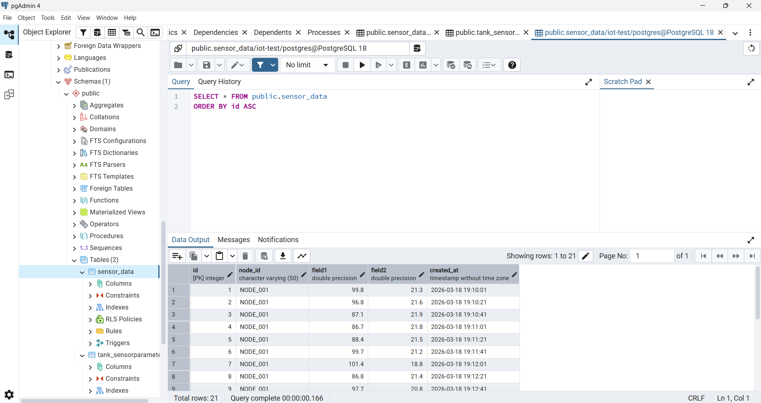
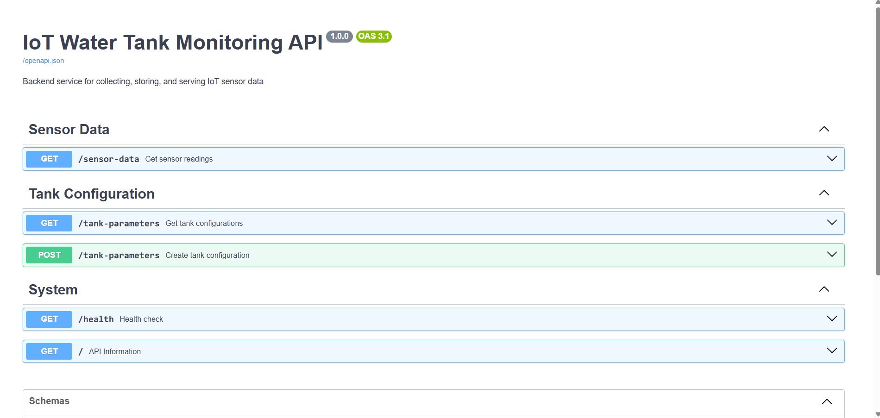
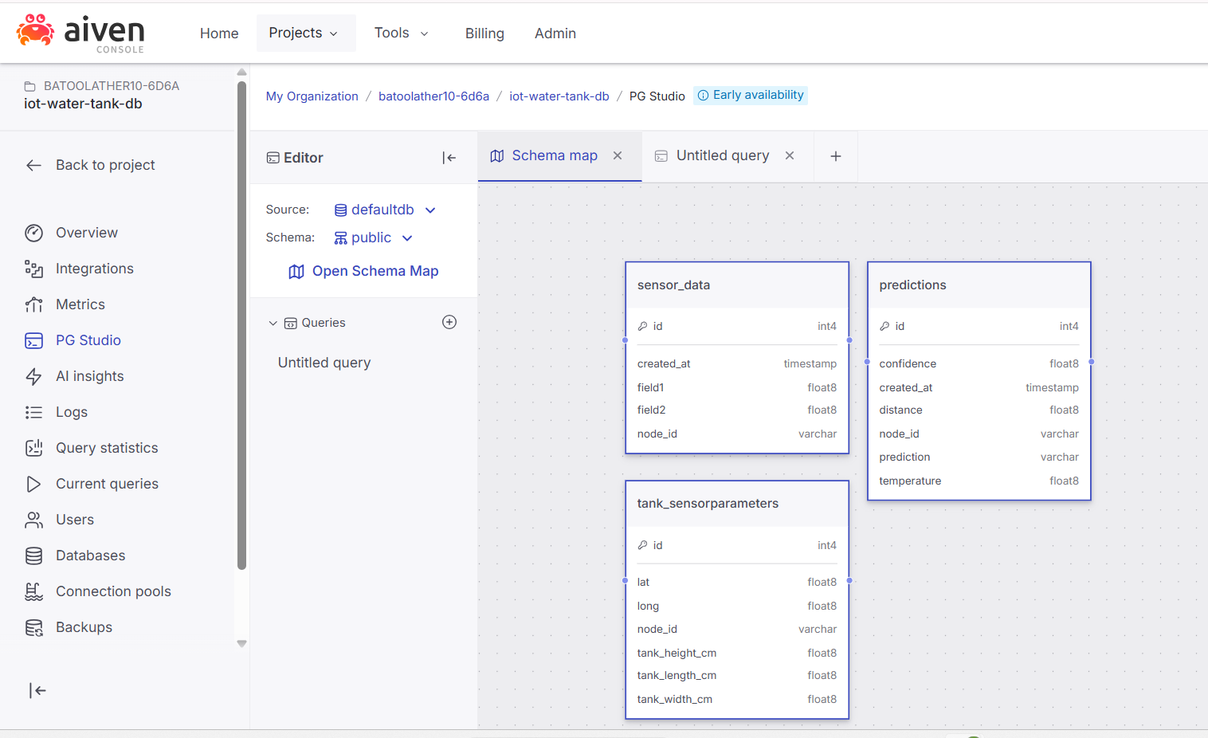

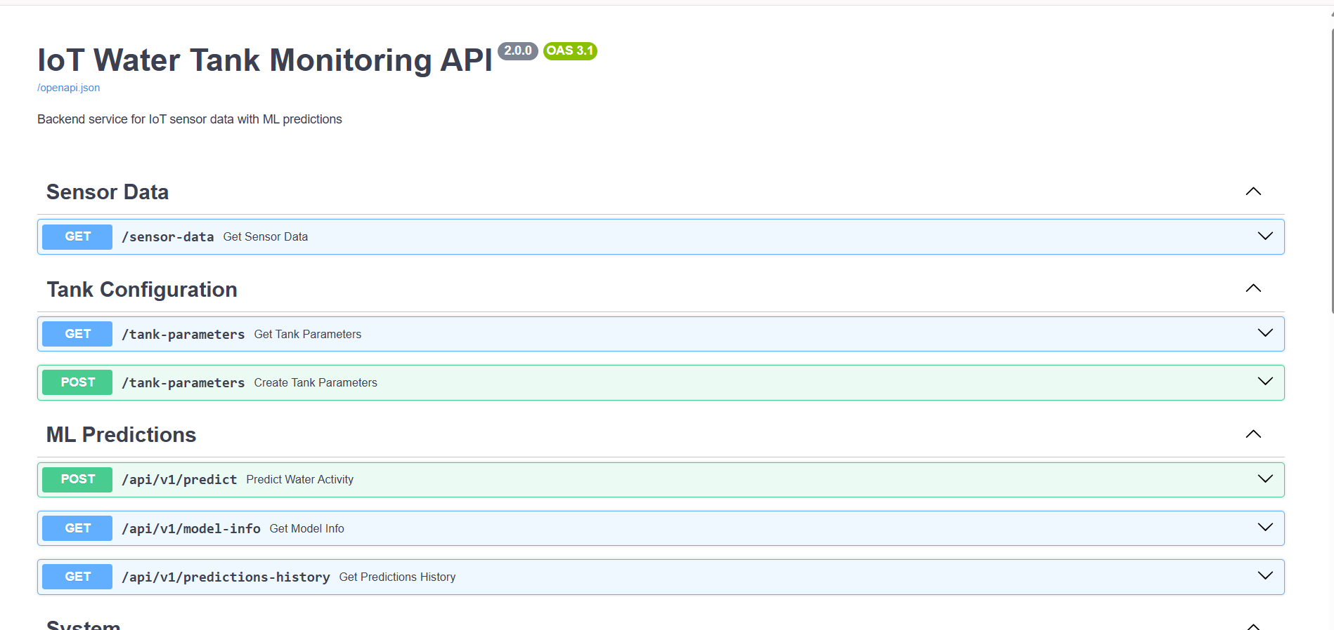
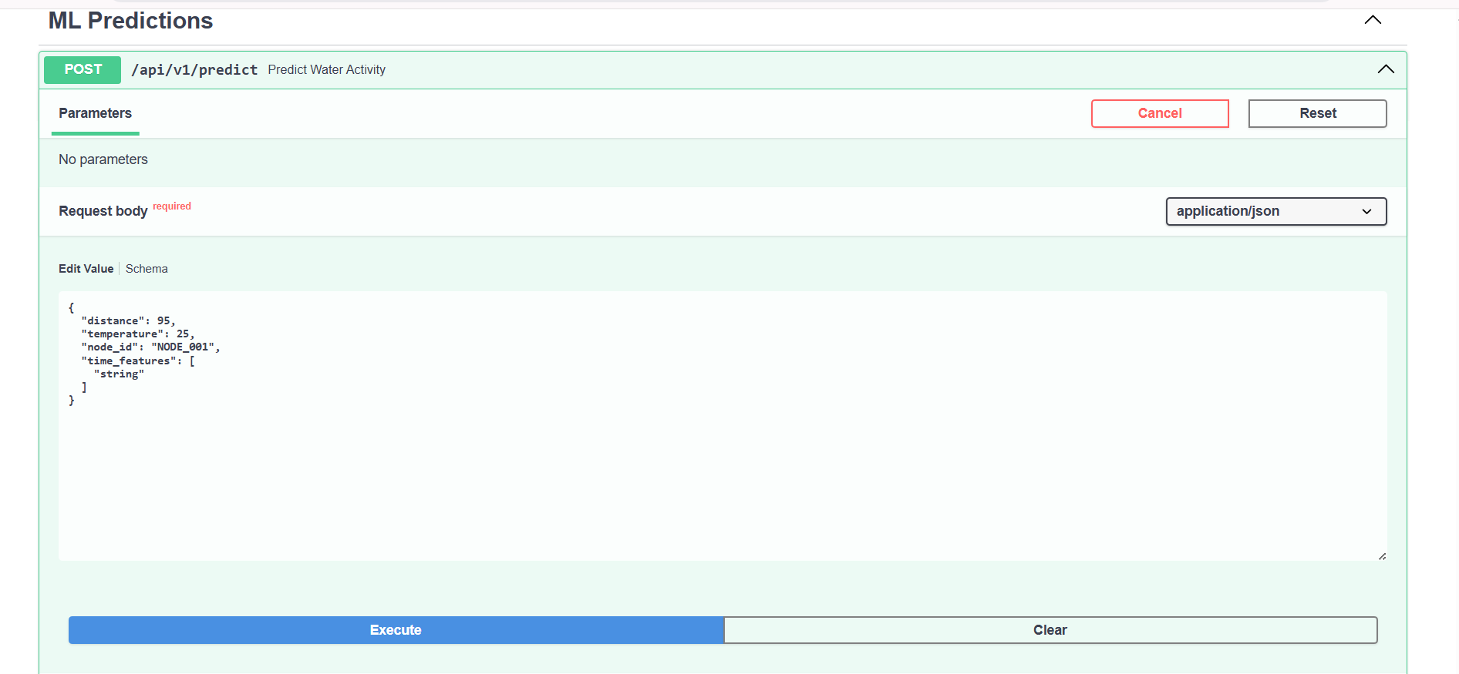
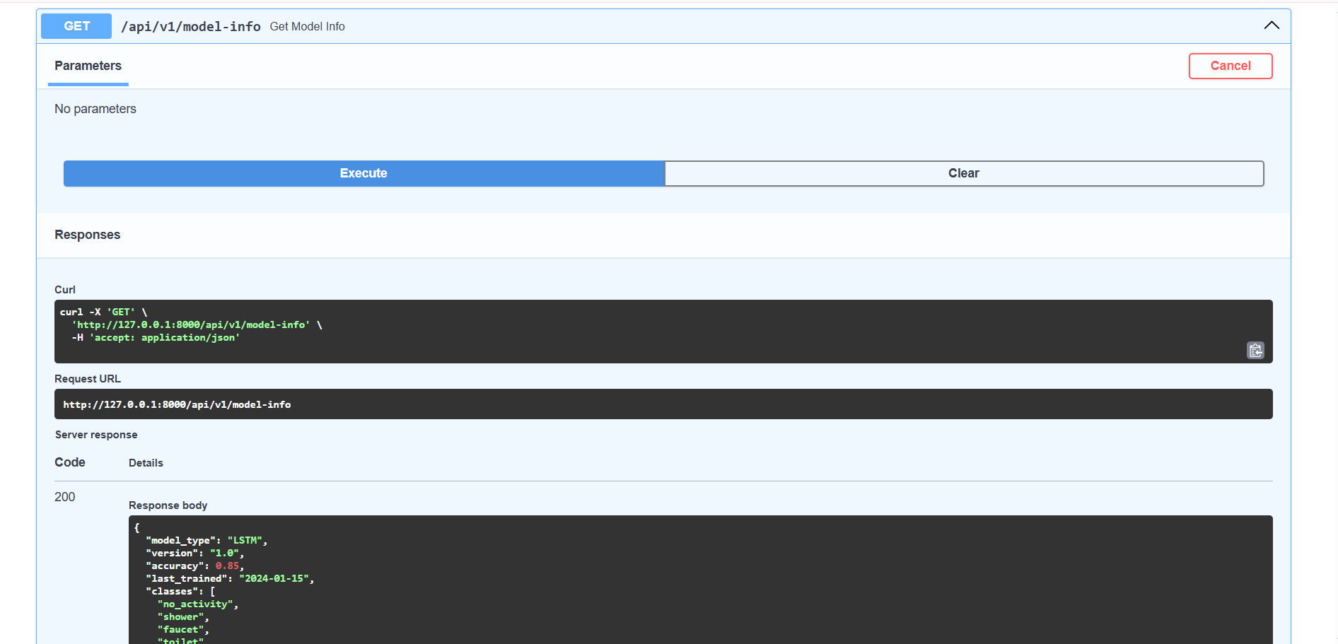

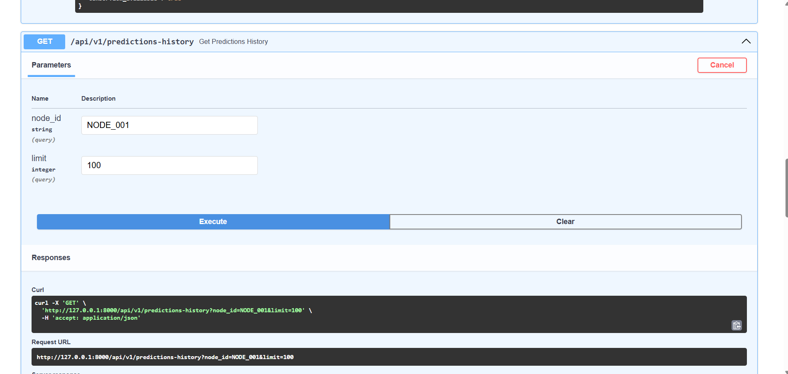
def make_prediction(distance: float, temperature: float, time_features: list = None):

global ml_model

if ml_model is None:
return {
"prediction": "error",
"confidence": 0.0,
"error": "Model not loaded"
}

try:
input_data = preprocess_sensor_data(distance, temperature, time_features)
prediction_probs = ml_model.predict(input_data, verbose=0)
prediction_index = np.argmax(prediction_probs[0])
confidence = float(prediction_probs[0][prediction_index])
prediction_class = MODEL_CLASSES[prediction_index]

return {
"prediction": prediction_class,
"confidence": confidence
}

except Exception as e:
print(f"[ML] Prediction error: {e}")
return {
"prediction": "error",
"confidence": 0.0,
"error": str(e)
}

Deployed URLs
- Backend API Base URL:
http://127.0.0.1:8000/docs#/
- API Documentation (Swagger UI):
http://127.0.0.1:8000/docs#/ML%20Predictions/predict_water_activity_api_v1_predict_post
- Frontend Application URL:
http://localhost:3000

Machine Learning Improvements and Experimental Results
Overview
To improve the performance of the water activity classification system, multiple deep learning architectures were explored and optimized. The models evaluated include LSTM, CNN, and GRU, with systematic tuning of hyperparameters such as number of layers, units, dropout rates, learning rate, and training epochs.

Key Improvements Made
1. Increased Model Depth and Capacity
- Expanded from 2-layer to 3-layer architectures
- Increased units (e.g., 64 → 128 → 64 → 32) for better feature extraction
2. Regularization Techniques
- Introduced Dropout (0.2–0.3) to reduce overfitting
3. Learning Rate Optimization
- Reduced learning rate (0.001 → 0.0005) for stable convergence
4. Training Strategy Enhancements
- Increased epochs for better learning
- Applied EarlyStopping to avoid overtraining
- Used validation split for improved generalization
5. Model Architecture Exploration
- Compared performance of:
  - LSTM (temporal learning)
  - GRU (efficient sequence modeling)
  - CNN (pattern extraction from time-series)

Experimental Results
Experiment | Model | Layers | Units | Dropout | Learning Rate | Epochs | Accuracy | Notes
1 | LSTM | 2 | 64, 32 | 0.0 | 0.001 | 50 | 85% | Baseline model
2 | LSTM | 3 | 128, 64, 32 | 0.3 | 0.001 | 30 | 98.31% | Best performing model
3 | CNN | 3 | 64, 128, 128 | 0.3 | 0.0005 | 10 | 89.58% | Improved performance with fewer epochs
4 | GRU | 3 | 128, 64, 32 | 0.2 | 0.0005 | 30 | 92.50% | Improved with learning rate

Observations
- The LSTM model (Experiment 2) achieved the highest accuracy of 98.31%, showing significant improvement after increasing depth and applying dropout.
- The GRU model achieved strong performance with 92.50% accuracy, offering a good balance between accuracy and computational efficiency.
- The CNN model achieved 89.58% accuracy with only 10 epochs, indicating efficient learning of spatial patterns in time-series data.
- The baseline LSTM model performed the lowest at 85%, highlighting the importance of hyperparameter tuning.
- Lower learning rates and proper regularization significantly improved model generalization.

Conclusion
The experimental results demonstrate that hyperparameter tuning and architectural improvements significantly enhance model performance.
Among all tested models, the optimized LSTM (3-layer) achieved the highest accuracy of 98.31%, making it the best-performing model.
The GRU model also delivered strong results with lower computational cost, making it a practical alternative for deployment. The CNN model showed efficient learning with fewer epochs, while the baseline LSTM highlighted the need for optimization.

API Endpoints Added
The backend system was extended with multiple REST API endpoints to support real-time prediction, monitoring, and data retrieval. These endpoints were developed using FastAPI and enable seamless interaction between the machine learning model and the frontend interface.
1. Predict Water Activity
Endpoint: POST /api/v1/predict
- Description:
Predicts water usage activity based on sensor input data using the trained machine learning model.
- Input Parameters:
{
"distance": float,
"temperature": float,
"time_features": [hour, minute, day]
}
- Response:
{
"prediction": "activity_label",
"confidence": float
}
- Functionality:
  - Preprocesses input data
  - Performs model inference
  - Returns predicted class and confidence score
  - Optionally stores prediction in database
2. Model Information
Endpoint: GET /api/v1/model-info
- Description:
Provides metadata about the deployed machine learning model.
- Response Includes:
  - Model type (LSTM / CNN / GRU)
  - Version
  - Accuracy
  - Last trained date
  - Supported classes
- Purpose:
  - Helps monitor model performance
  - Useful for debugging and system transparency
3. Predictions History
Endpoint: GET /api/v1/predictions-history
- Description:
Retrieves previously generated predictions stored in the database.
- Query Parameters:
  - limit (optional): Number of records to fetch
- Response Includes:
  - Sensor data (distance, temperature)
  - Predicted activity
  - Confidence score
  - Timestamp
- Purpose:
  - Enables historical analysis
  - Supports visualization in frontend dashboards
4. Health Check Endpoint
Endpoint: GET /api/v1/health
- Description:
Checks the status of the backend service.
- Response:
{
"status": "healthy"
}
- Purpose:
  - Ensures server is running
  - Useful for deployment monitoring and debugging
Summary
These endpoints collectively enable:
- Real-time prediction using ML models
- Model monitoring and transparency
- Data persistence and retrieval
- System health verification
This modular API design ensures scalability, maintainability, and easy integration with frontend applications.

Frontend Summary – IoT Water Tank Monitoring System
Overview
The frontend of the system is a responsive and interactive web dashboard built using React.js. It provides a user-friendly interface to visualize real-time sensor data, monitor tank status, and view machine learning predictions.

User Interface Design
- Designed with a modern dashboard layout including:
  - Navbar (branding + navigation)
  - Sidebar (menu and controls)
  - Main content area (data visualization)
- Color scheme aligned with institutional branding (blue & white theme) for a professional look.
- Clean and minimal UI for better readability and usability.

Data Visualization
- Displays real-time:
  - Water level (distance)
  - Temperature readings
- Shows historical trends using charts and graphs.
- Visual indicators (like status labels) for quick understanding of tank conditions.

ML Prediction Display
- Displays predicted water usage activities such as:
  - Filling
  - Flush
  - Washing machine
  - Geyser
- Shows confidence score for each prediction.
- Updates dynamically based on incoming sensor data.

Authentication Interface
- Includes:
  - Login page
  - Registration page
- Handles token storage using localStorage.
- Ensures secure access to protected features.
API Integration
- Communicates with backend using REST APIs (fetch/axios).
- Handles:
  - Data fetching
  - Error handling
  - Loading states
- Dynamically updates UI without page reloads.

Responsiveness
- Fully responsive design:
  - Works on desktop, tablet, and mobile devices
- Sidebar toggle (hamburger menu) improves usability on smaller screens.

Component-Based Architecture
- Built using reusable React components such as:
  - Navbar
  - Sidebar
  - Data Cards
  - Charts
- Improves maintainability and scalability of the application.
Key Features
- Real-time dashboard updates
- Interactive UI with smooth navigation
- Modular and scalable design
- Integration with IoT + ML backend
- User-friendly and visually consistent interface
Conclusion
The frontend provides an intuitive and efficient interface for monitoring water tank activity. By combining real-time visualization, ML prediction display, and responsive design, it enhances user experience and enables effective decision-making in smart water management systems.

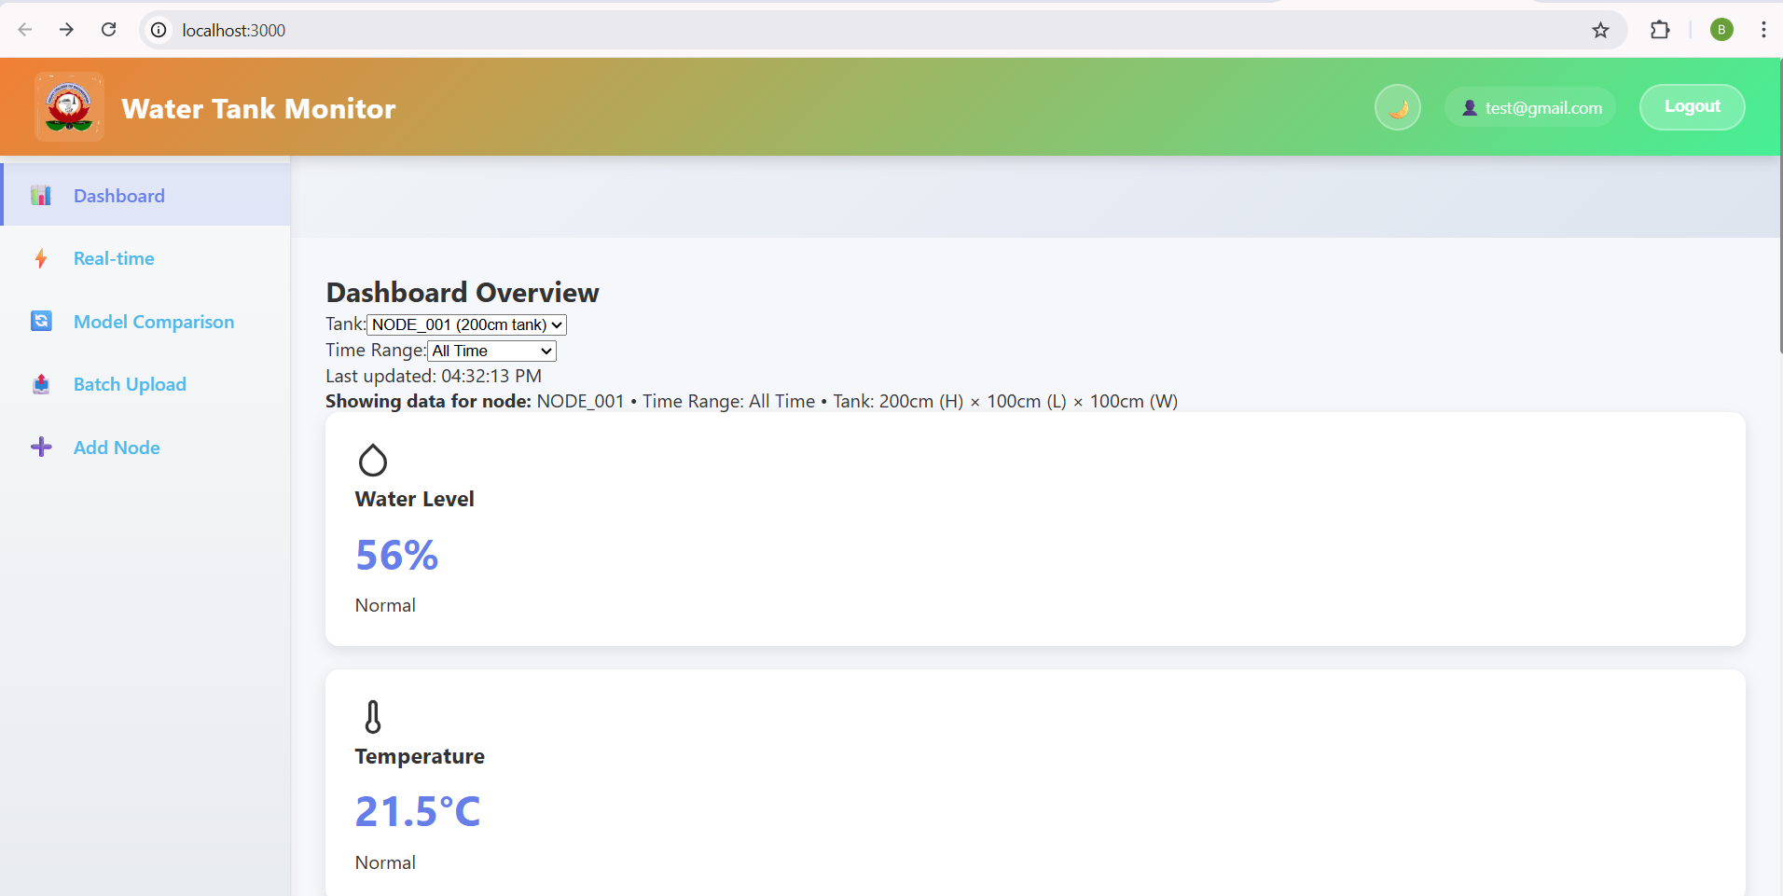

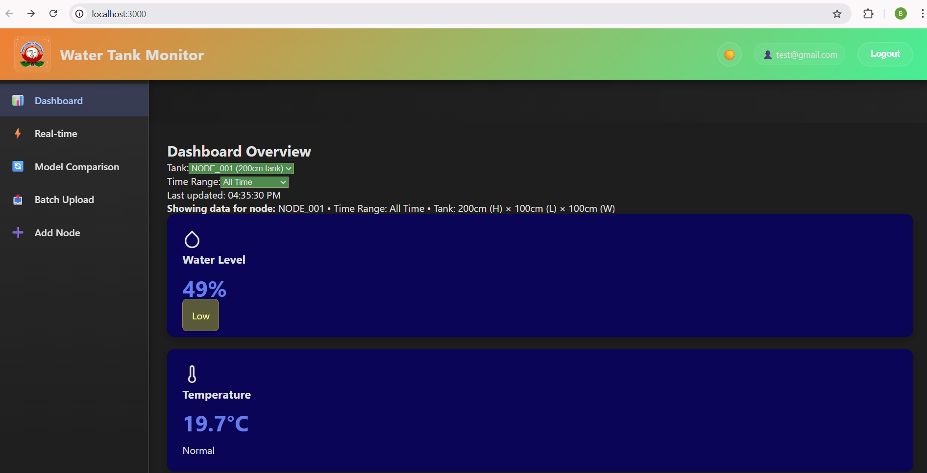
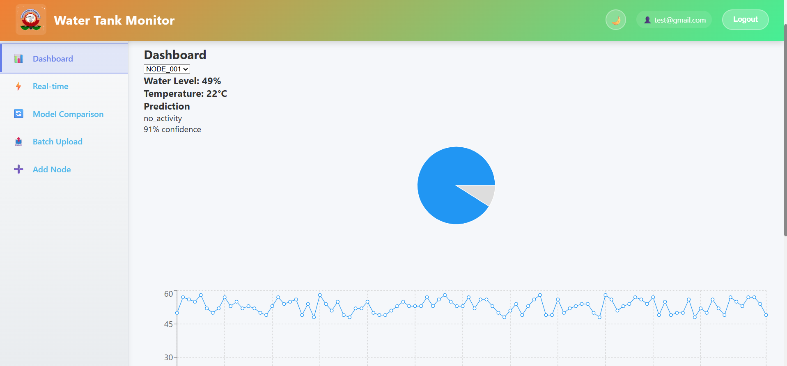
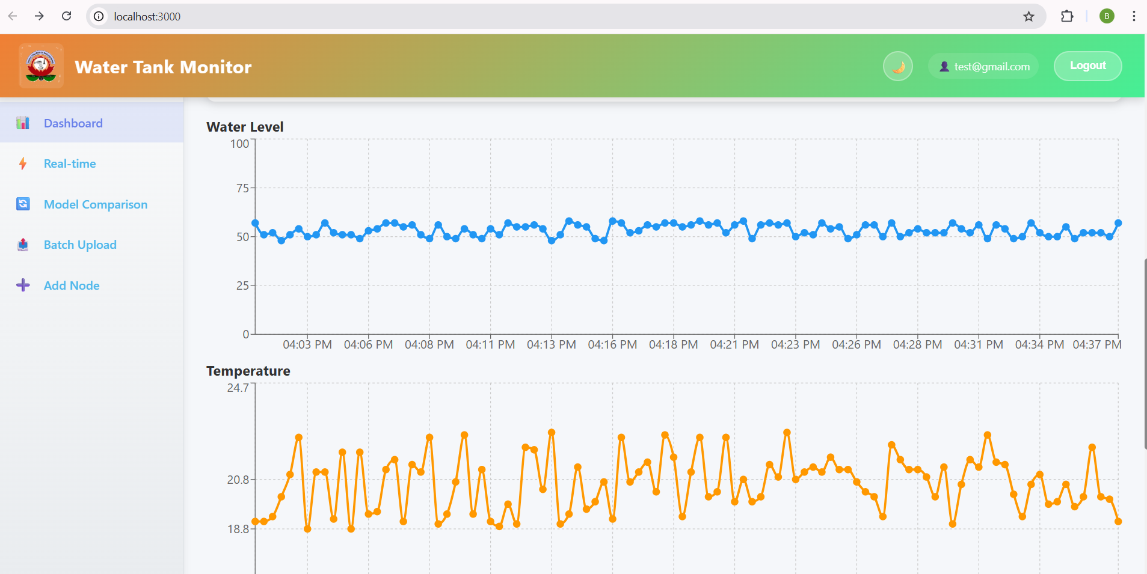
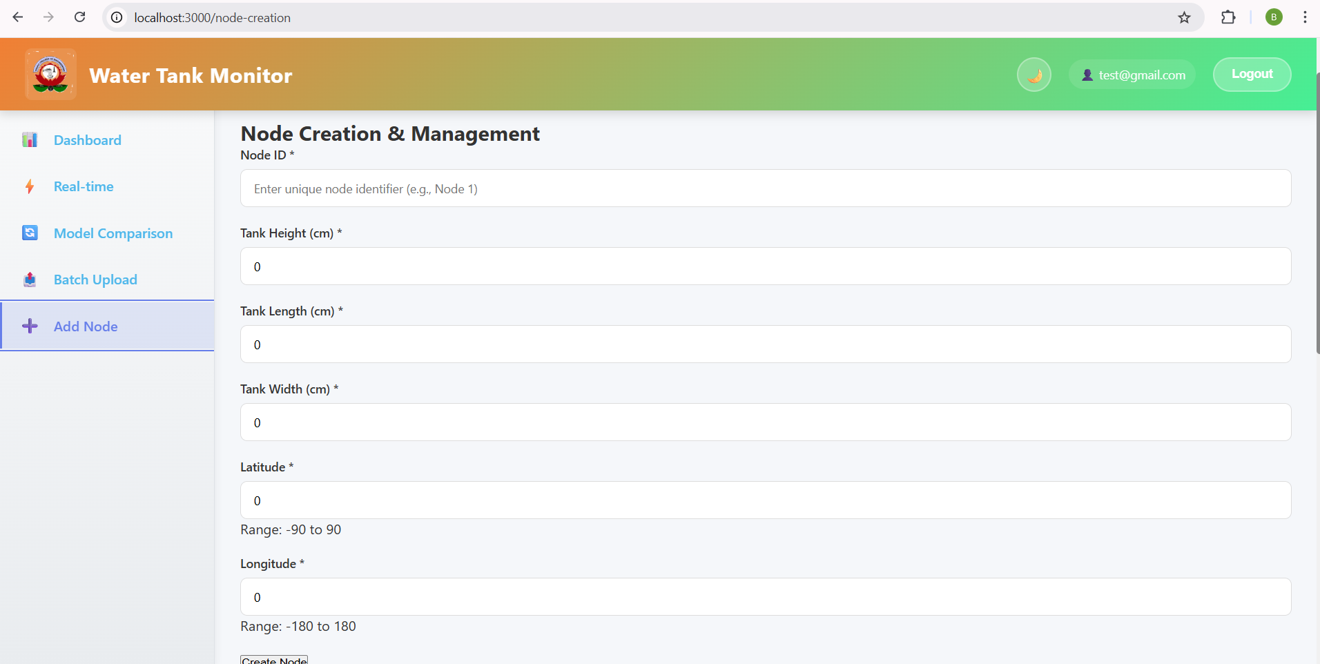
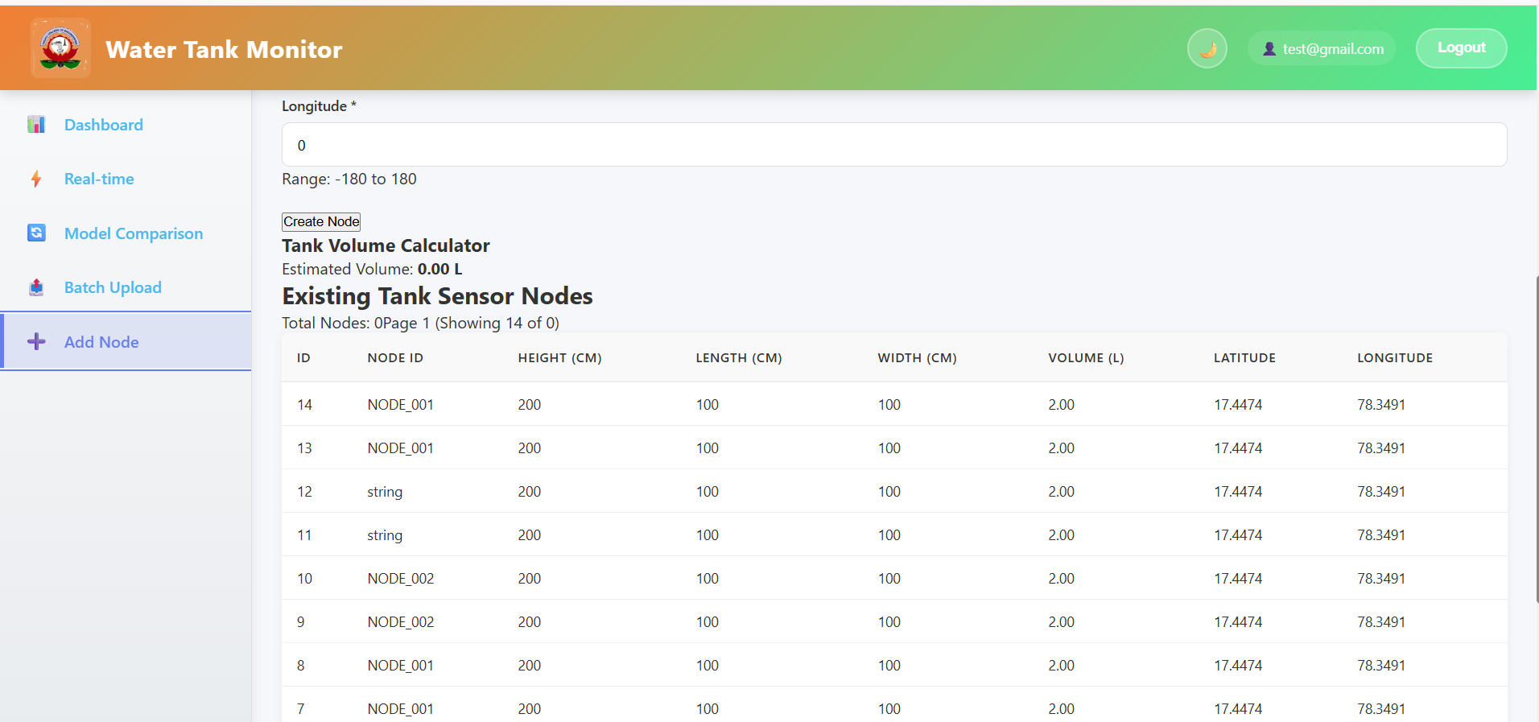
https://iot-water-level-monitoring.onrender.com
https://github.com/BatoolAther10/IoT_Water_level_monitoring

Challenges Faced and Solutions Implemented
During the development of the Smart Water Activity Detection System, several technical challenges were encountered across machine learning, backend integration, and cloud database deployment. The following are key issues and how they were resolved:
1. Low Model Accuracy in Initial Stages
- Problem:
The baseline LSTM model achieved only ~85% accuracy due to a shallow architecture and insufficient training.
- Solution:
  - Increased the number of LSTM layers and units (64 → 128,64,32)
  - Added Dropout for regularization
  - Increased training epochs and reduced learning rate
  - Introduced EarlyStopping and learning rate scheduling
- Outcome:
Improved accuracy to 87.86%+ with better generalization.

2. Overfitting During Training
- Problem:
The model performed well on training data but poorly on validation data, indicating overfitting.
- Solution:
  - Added Dropout layers (0.2–0.3)
  - Used validation split during training
  - Applied EarlyStopping to prevent excessive training
- Outcome:
Reduced overfitting and improved validation performance.

3. Input Shape Mismatch Errors
- Problem:
Errors occurred while feeding data into LSTM/GRU/CNN models due to incorrect input shapes.
- Solution:
  - Standardized input format to (samples, timesteps, features)
  - Reshaped input data consistently during preprocessing and API inference
- Outcome:
Ensured stable training and correct predictions across all models.

4. Backend Integration with ML Model
- Problem:
Integrating the trained deep learning model into the FastAPI backend caused issues such as incorrect input formatting and runtime errors.
- Solution:
  - Loaded the model at application startup using load_model()
  - Implemented preprocessing inside the /api/v1/predict endpoint
  - Ensured consistent feature order between training and inference
- Outcome:
Enabled reliable real-time predictions through API endpoints. 5. Aiven PostgreSQL Connection Errors
- Problem:
While integrating the cloud database (Aiven PostgreSQL), multiple connection issues were encountered:
  - SSL connection errors
  - Authentication failures
  - Incorrect database URL formatting
  - Timeout issues when connecting from backend
- Solution:
  - Used the correct connection string provided by Aiven
  - Enabled SSL mode (sslmode='require') in the connection
  - Verified credentials (username, password, host, port)
  - Tested connection separately before integrating into FastAPI
  - Handled exceptions using try-except blocks to prevent crashes
- Outcome:
Successfully established a stable connection with the cloud database and enabled storage of prediction history.
6. Database Insertion and Schema Issues
- Problem:
Errors occurred while inserting prediction data due to mismatched schema and missing tables.
- Solution:
  - Created a structured predictions table using SQL
  - Ensured correct data types for each column
  - Added CREATE TABLE IF NOT EXISTS logic in backend
- Outcome:
Reliable storage and retrieval of prediction data.
Conclusion
Addressing these challenges significantly improved the system’s robustness, scalability, and real-time performance. The integration of machine learning, backend APIs, and cloud database services resulted in a fully functional and production-ready system.

